**Testing Attendance Scan**

**Step 1**: Lecturer log into System

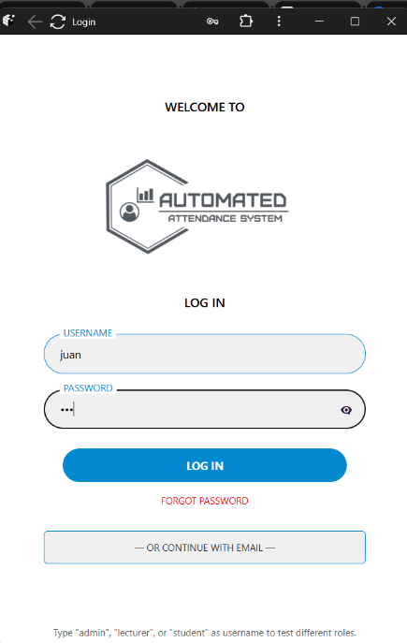

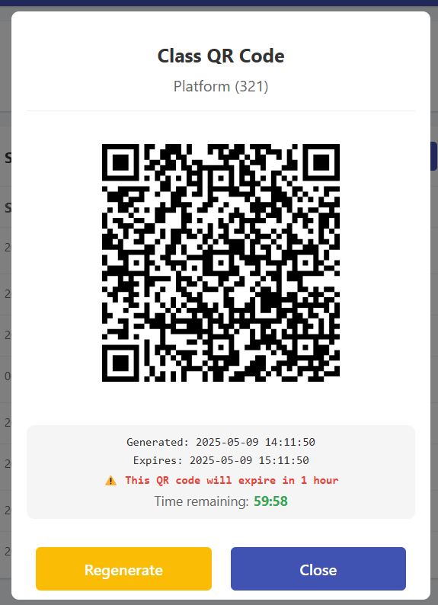**Step 2:** Lecturer Generate the qr code from the class they handle

**Step 3:** Lecturer show the QRCode generated code to the student soo that the student can scan it.

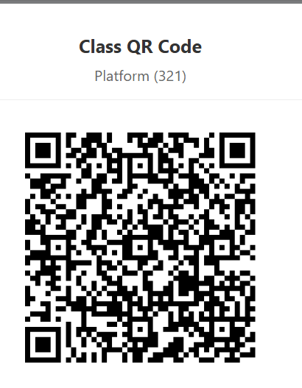

**Step 4:** Student will log in to the system

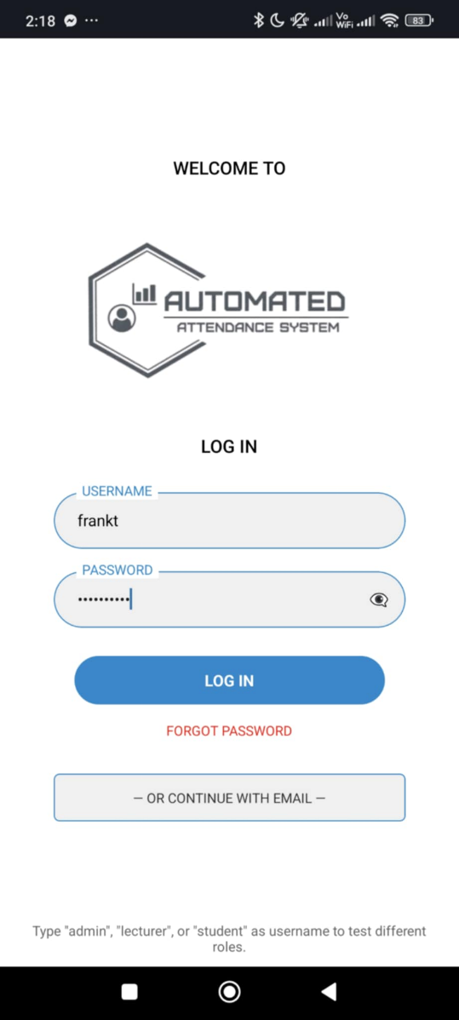

**Step 5:** Student will open the class where they enroll to open the camera icon.

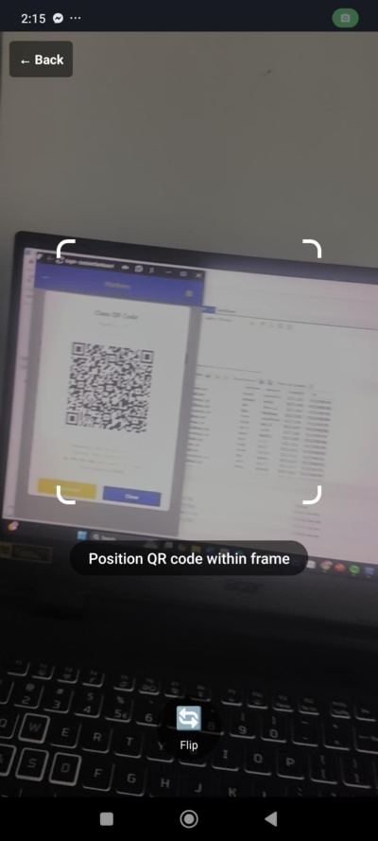

**step 6** Tester Open workbench view on to the attendance table –



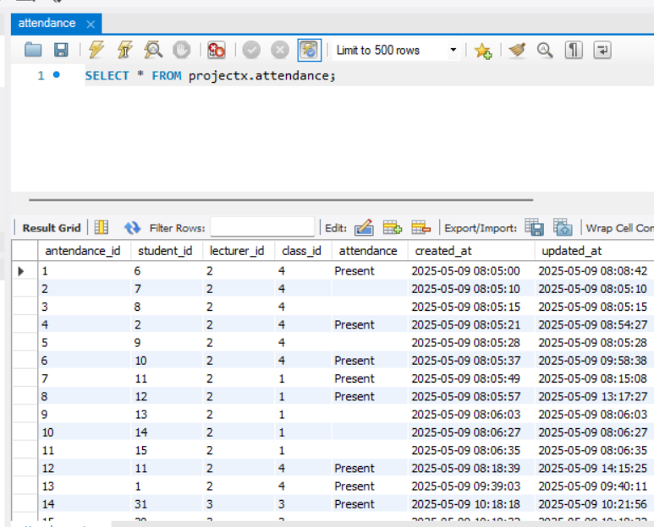

**step 7:** screen shot the table attendance state noting the existing attendance state

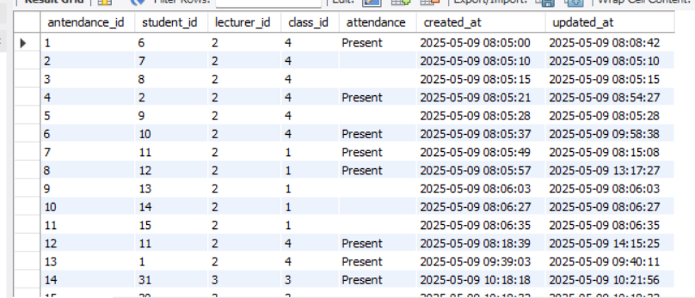

**Step 8:** Student now scans t

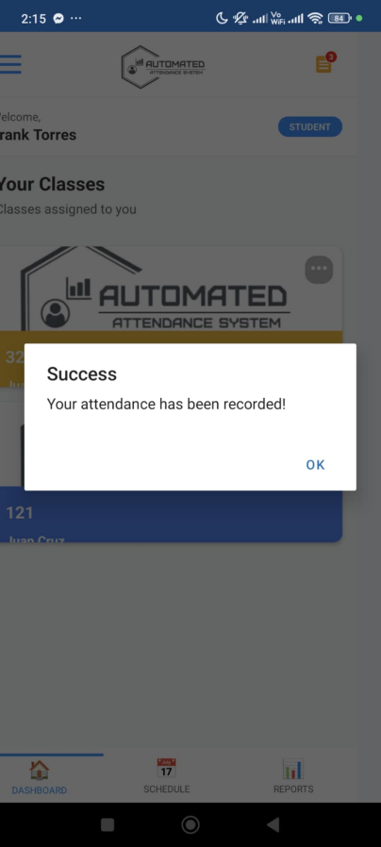

**Step 9:** Tester Refreshes the attendance in My Workbench

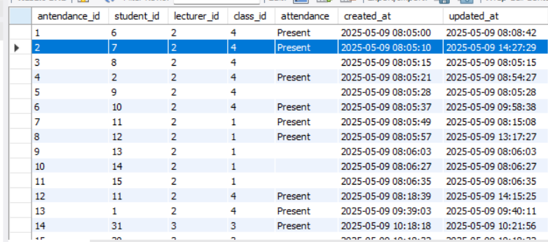

**step 10** EXPECT to see as new row reflecting the new attendance: student

sheduleid date

present or absent

